THIRD PRIZE WINNER OF JUNE MONTH CASH AWARD RIDER MRS.MADHUMITHA’S SOLUTION
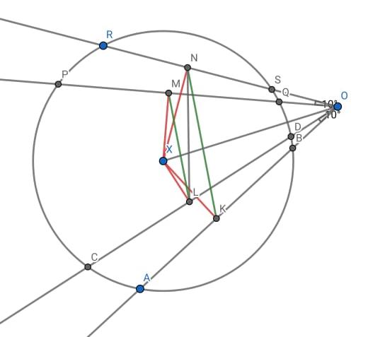

Given O is a point outside the circle, OSR, OQP, ODC, OBA are secant to the given circle also given $∠COA=∠POR=θ$ (let) given K, L, M,N are mid points of AB, CD, PQ, RS respectively.
Construction:
Let x be centre of circle such that if drop perpendicular from x to AB, CD, PG, RS. It passes through K, L, M, N respectively.
Join XM, XN, XL, XK & LN.
$∴$ $∠XNO=∠XMO=90°$
$⇒XMNO$forms cyclic quadrilateral
$⇒$ X, M,N,O lies on a circle say C1 whose diameter is XO ($∵∠XMC=∠XNO=90°$) --- (A)
Similarly, $∠XLO=∠XKO=90°$
$⇒$XLKO forms cyclic quadrilateral
$⇒X,L,K,O$ lies on circle say C2 whose diameter is XO --------------- (B)
Its' clear that we can draw only one circle through X&O having XO as diameter
$∴$ C1= C2 (both circle are same)
$⇒$ M,N,O,K,L,X lies on same circle C1=C2=C (let)
$∠MON=∠MLN=θ$ (angle subtended by arc MN on circumference)
And $∠LOK=∠LNK= θ$ (angle subtended by arc LK on circumference)
$⇒ ∠$ MON = $∠MLN= ∠LNK= ∠LOK=θ$
alternate angles
Alternate angles are equal. LN is transversal
$⇒$ML$∥$NK ---- Hence Proved.

